Project Deliverable 2: Regression Modeling and Performance Evaluation
Sandeep Parupalli
University of the Cumberlands
2026 Spring - Advanced Big Data and Data Mining (MSCS-634-B01)
Satish Penmatsa (Instructor)
March 28, 2026

Project Deliverable 2: Regression Modeling and Performance Evaluation
This deliverable focuses on building and evaluating regression models with the Online Retail dataset. The goal is to predict customer spending behavior from purchase patterns, pricing behavior, and time-based activity. To make the regression task more meaningful, the original invoice-level data was cleaned and transformed into a customer-level modeling table. The analysis then compared a baseline feature set with engineered features, evaluated multiple regression models, and used cross-validation to check whether the models could generalize beyond a single train/test split.
The project repository for this deliverable is available at https://github.com/Sandeep271/Project.

Dataset Description and Data Preparation
The dataset used in this deliverable is the Online Retail dataset. It contains transaction-level records from a UK-based online retailer. Each row represents one invoice line and includes an invoice number, stock code, product description, quantity, invoice date, unit price, customer identifier, and country. The original dataset contained 541,909 rows and 8 columns.
Several cleaning steps were completed before modeling. Duplicate rows were removed so repeated records would not distort the results. Rows with missing Description or CustomerID values were dropped because those fields are necessary to identify valid transactions and to aggregate records at the customer level. Rows with non-positive Quantity or UnitPrice values were also removed because they usually represent cancellations, returns, or invalid entries for the kind of spending prediction used in this deliverable.
After cleaning, the dataset contained 392,692 valid transaction rows. The cleaned transaction data was then aggregated to the customer level, which produced 4,338 customer records. This structure was more suitable for regression because the target variable became total customer spending instead of the value of a single invoice line.
Table 1
Dataset Summary for Deliverable 2
Item | Value
Original dataset shape | 541,909 rows × 8 columns
Cleaned transaction dataset | 392,692 rows × 10 columns
Customer-level modeling table | 4,338 rows × 9 columns
Target variable | LogTotalSpent
Regression unit of analysis | Customer

Feature Engineering
Feature engineering was used to improve the information available to the regression models. The baseline feature set included NumTransactions, TotalQuantity, AvgUnitPrice, and ActiveMonths. These variables capture how often each customer purchased, how much they bought overall, the average price level of the products they purchased, and how many months they remained active in the dataset.
Two additional features were created to strengthen the models. AvgQuantityPerTransaction measures average purchase intensity by dividing total quantity by the number of transactions. QuantityPriceInteraction captures the combined effect of volume and price by multiplying TotalQuantity by AvgUnitPrice. A log transformation was also applied to TotalSpent to create LogTotalSpent, the final target variable. This transformation reduced the strong right skew in raw spending and produced a target variable that was more stable for regression.
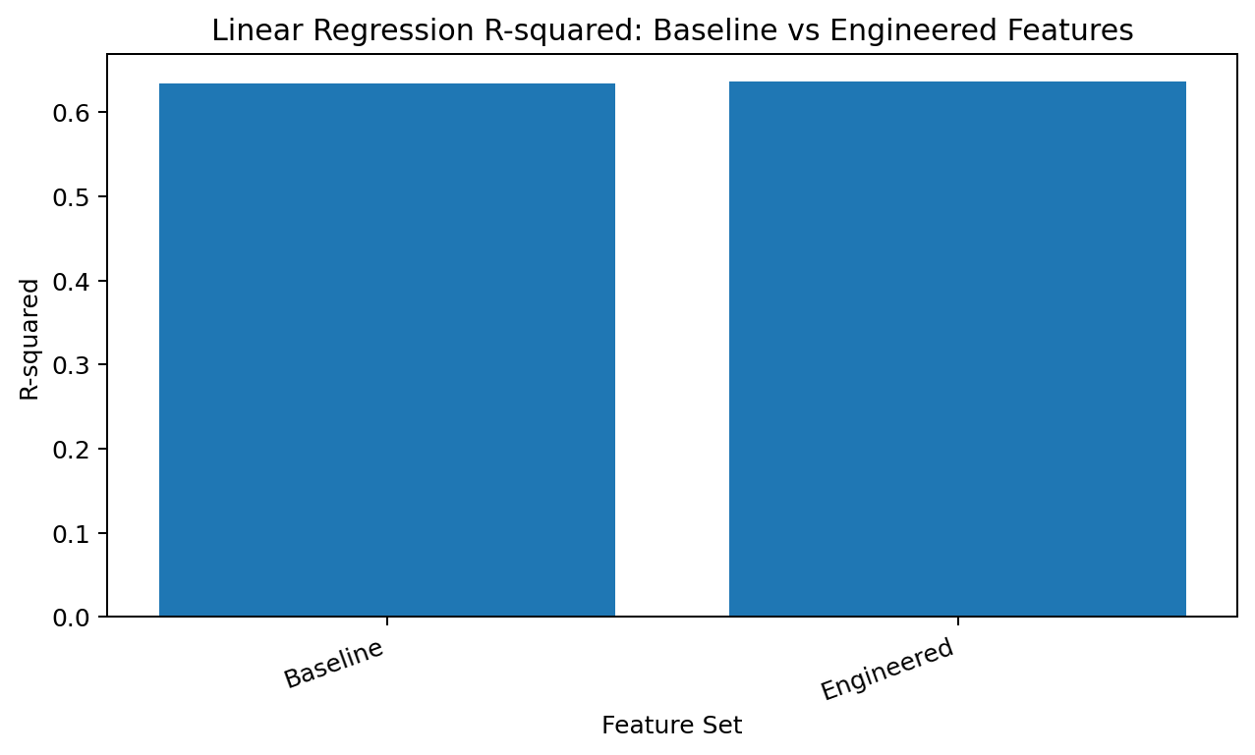
Figure 1. Feature engineering slightly improved linear regression R-squared.
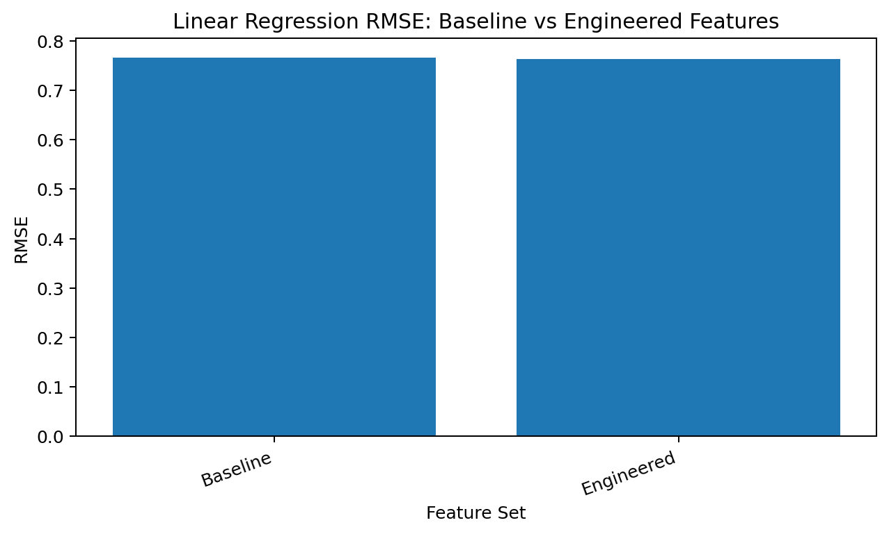
Figure 2. Feature engineering also produced a small reduction in RMSE.
Table 2
Baseline Versus Engineered Feature Set Results
Feature Set | R-squared | RMSE | MAE
Baseline | 0.6338 | 0.7665 | 0.5827
Engineered | 0.6370 | 0.7632 | 0.5823

The engineered feature set performed slightly better than the baseline feature set. The increase in R-squared was small, but it was consistent with the reduction in RMSE and MAE. Because the engineered variables added value without overcomplicating the model, the final model comparison used the engineered feature set.

Regression Modeling Approach
Three regression models were built and compared on the same engineered feature set. Linear Regression was used as the baseline model because it provides a direct and interpretable benchmark. Ridge Regression was added to test whether L2 regularization would improve stability by shrinking coefficients. Lasso Regression was included to test whether L1 regularization would improve prediction and simplify the model by reducing less useful coefficients.
The data was split into training and testing sets using an 80/20 split. Model performance was evaluated with R-squared, Mean Squared Error (MSE), Root Mean Squared Error (RMSE), and Mean Absolute Error (MAE). R-squared shows how much variation in the target is explained by the model. MSE and RMSE show the size of prediction errors, while MAE provides an average absolute prediction error that is often easier to interpret in plain language.
Table 3
Regression Model Performance on the Test Set
Model | R-squared | MSE | RMSE | MAE
Linear Regression | 0.6370 | 0.5825 | 0.7632 | 0.5823
Ridge Regression | 0.6370 | 0.5825 | 0.7632 | 0.5823
Lasso Regression | 0.6370 | 0.5825 | 0.7632 | 0.5823

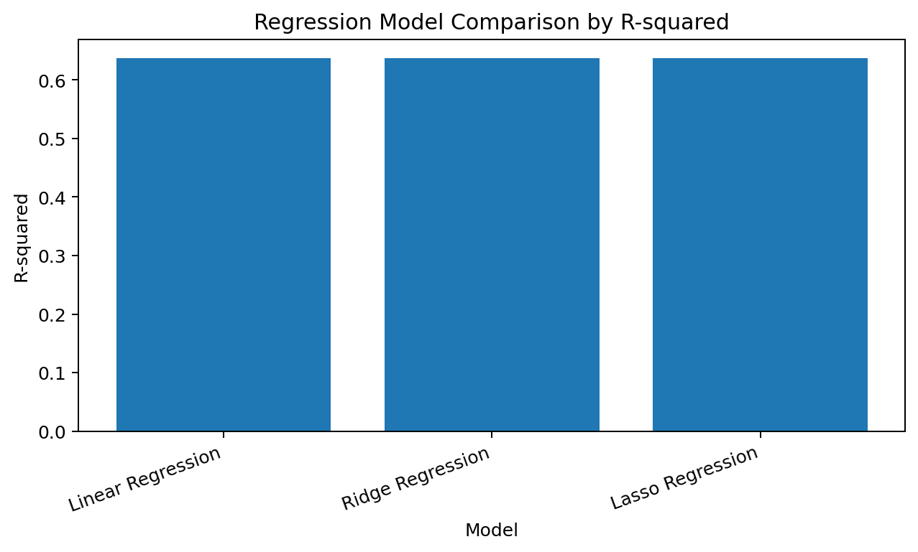
Figure 3. All three regression models produced nearly identical R-squared values.
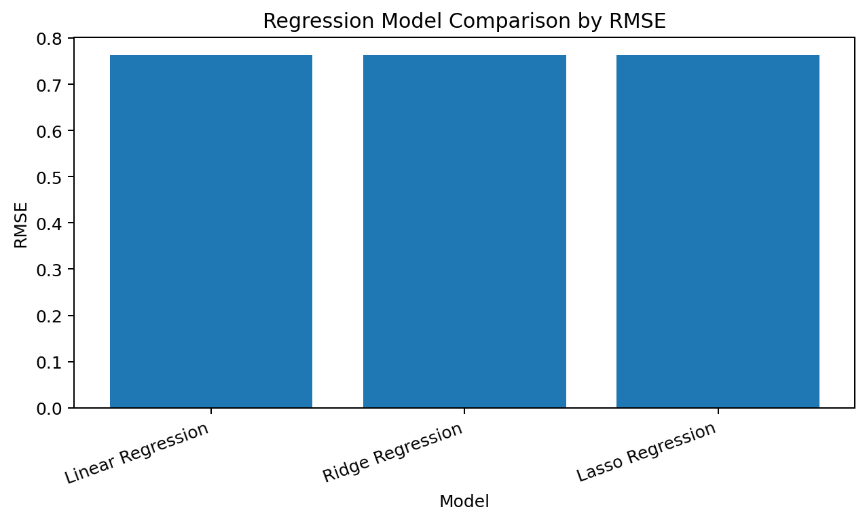
Figure 4. RMSE values were also extremely close across models, showing only minor differences in prediction error.
The model comparison shows that all three models performed almost identically on the test set. Lasso Regression had the highest R-squared and the lowest RMSE, but the advantage over the other models was extremely small. In practical terms, the results suggest that the relationship between the engineered customer-level features and log-transformed customer spending is fairly stable and close to linear.

Cross-Validation and Generalization
A single train/test split can give a useful snapshot of performance, but it does not fully show how stable the models will be on unseen data. To address that issue, 5-fold cross-validation was used with shuffled folds. This process repeatedly trains and evaluates the models on different subsets of the data and produces a more reliable estimate of generalization.
Table 4
Five-Fold Cross-Validation Results
Model | Mean CV R-squared | CV Standard Deviation
Linear Regression | 0.5710 | 0.1002
Ridge Regression | 0.5710 | 0.1002
Lasso Regression | 0.5710 | 0.1002

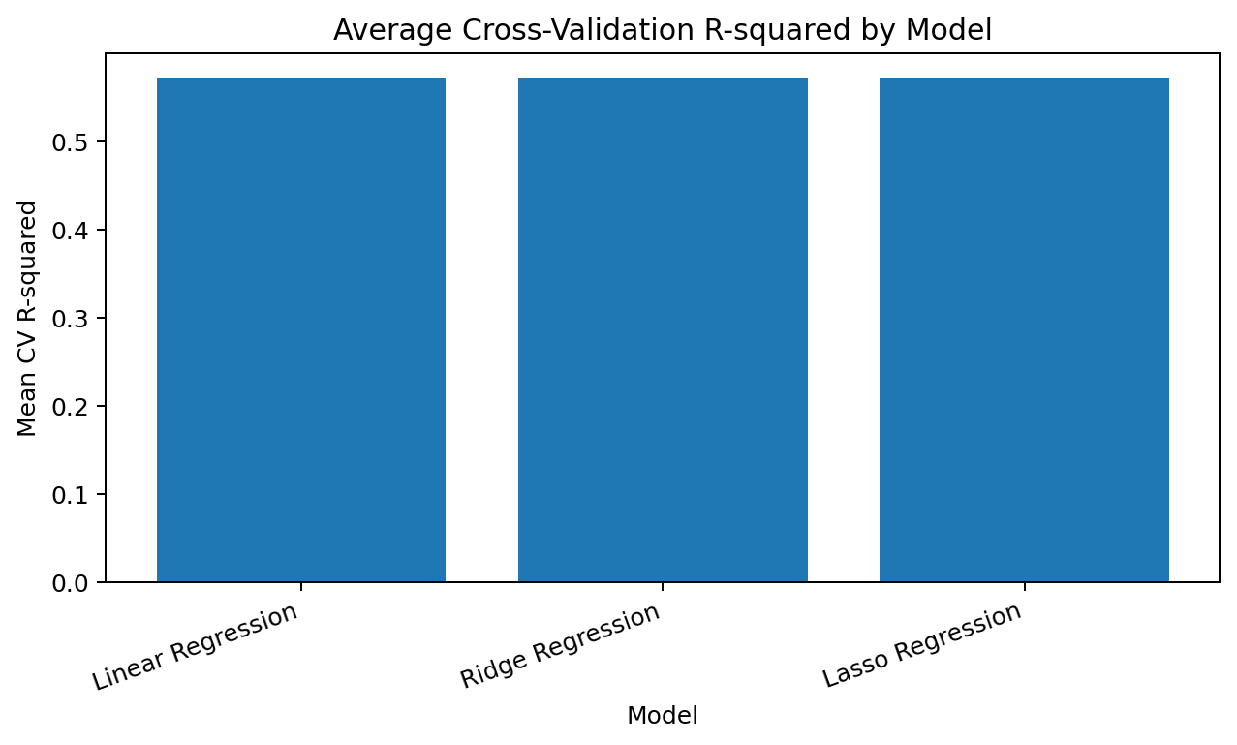
Figure 5. Average cross-validation R-squared values were nearly identical across the three regression models.
The cross-validation results were lower than the single-split test results, which is common when performance is averaged across several folds rather than measured on one favorable split. Even so, the differences between the models remained very small. Lasso Regression again had the strongest average result, but only by a tiny margin. This pattern supports the conclusion that regularization did not substantially change performance for this dataset.

Best Model Interpretation
Because Lasso Regression produced the best combination of R-squared and RMSE, it was treated as the best-performing model in this deliverable. The actual-versus-predicted plot below shows that the model captures the overall pattern of the data reasonably well. Points are concentrated around the diagonal reference line, which indicates that many predictions are close to the observed values. At the same time, there is still noticeable spread, especially for customers with unusually high or low spending.
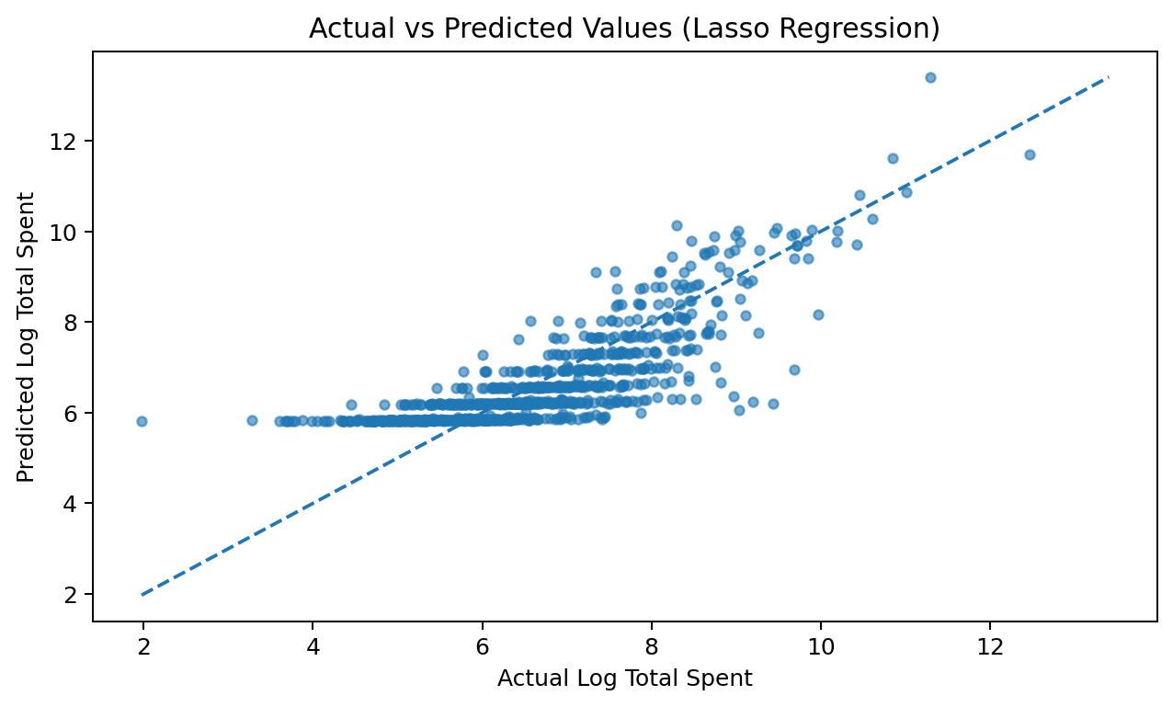
Figure 6. Actual versus predicted log spending values for the best-performing model, Lasso Regression.

Meaningful Insights and Key Observations
Several useful insights emerged from the regression analysis. First, customer spending can be predicted to a moderate degree from transaction frequency, total quantity purchased, average unit price, and activity across months. The test-set R-squared values near 0.637 indicate that these features explain a meaningful share of the variation in log-transformed customer spending.
Second, the engineered variables improved performance, even if the improvement was modest. That matters because it shows that purchase intensity and the joint effect of quantity and price contain information that is not fully captured by the simpler baseline variables. Third, the near-identical results across Linear Regression, Ridge Regression, and Lasso Regression suggest that the feature relationships are stable and that the data does not suffer from severe multicollinearity or nonlinearity in a way that regularization materially changes prediction quality.
Finally, the cross-validation results show that the models generalize reasonably well, but they also remind us that performance falls somewhat when tested repeatedly on different folds. That is an important practical finding because it gives a more realistic view of how the model may behave on new customer data.

Challenges and How They Were Addressed
One challenge in this deliverable was that the raw data was organized at the invoice-line level rather than the customer level. That structure was useful for transactions, but not ideal for predicting overall customer spending. The issue was addressed by aggregating the cleaned data into one row per customer and summarizing customer behavior into modeling variables.
A second challenge was the strong right skew in total spending. A small number of customers spent much more than the rest, which could have made the regression unstable and heavily influenced by outliers. This issue was addressed by log-transforming TotalSpent before modeling. A third challenge was that the three regression models produced extremely similar results, which can make model selection feel less meaningful. Instead of forcing a large difference where there was none, the analysis reported that the performance gap was minimal and interpreted that result honestly.
Another practical challenge was balancing detail and clarity. Because this deliverable required both modeling rigor and clear explanation, the final notebook and this written report were organized so that each step, metric, and chart had a clear purpose and interpretation.

Conclusion
This deliverable successfully developed and evaluated multiple regression models for predicting customer spending behavior. Feature engineering slightly improved performance over the baseline feature set, which supports the value of using customer behavior variables that capture purchase intensity and price-volume interaction. Among the final models, Lasso Regression performed best on both the test split and cross-validation, although its advantage was extremely small.
The overall results show that regression can explain a meaningful portion of customer spending patterns, but not all of them. That is a realistic outcome for retail behavior, where customer spending is influenced by many factors beyond the variables available in this dataset. Even so, the deliverable demonstrates a sound modeling process, appropriate evaluation, and a balanced interpretation of results.

Appendix: Submission Materials
The GitHub repository for this deliverable contains the Deliverable 2 notebook and README file required for submission. Repository link: https://github.com/Sandeep271/Project

